**Export a knowledge base**

You may want to create a copy of your knowledge base for several reasons:

* Copy a knowledge base from QnA Maker GA to Custom question answering
* To implement a backup and restore process
* Integrate with your CI/CD pipeline
* When you wish to move your data to different regions

1. Go to corresponding project to perform export.

1. Select the project and click on “Export”.

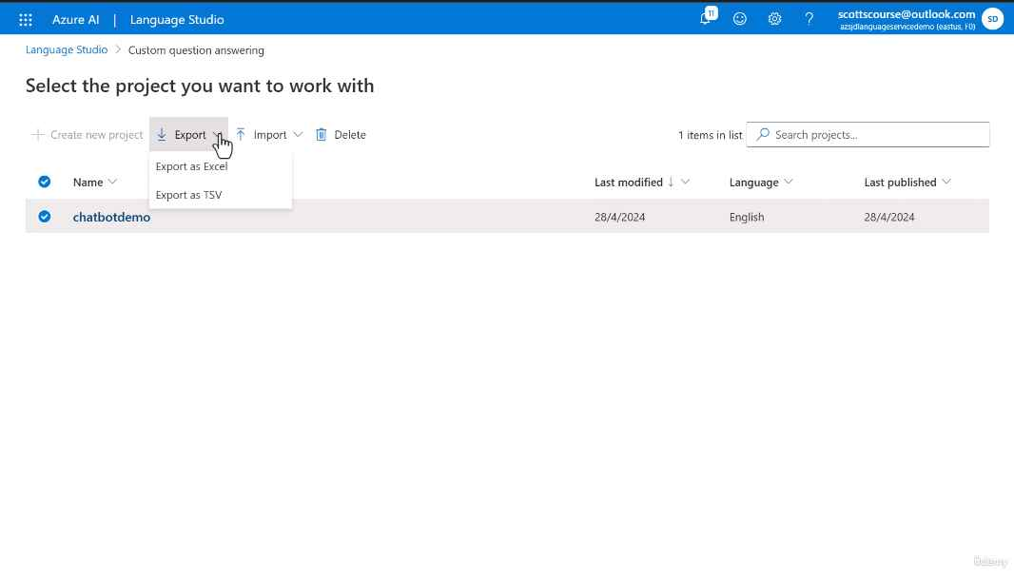

1. Click on “Export as Excel”. It will export file to local.

1. Export file contains questions, answers, metadata, follow-up prompts, and the data source names. The QnA IDs that are exported with the questions and answers may be used to update a specific QnA pair using the [update API](https://learn.microsoft.com/en-us/rest/api/qnamaker/knowledgebase/update). The QnA ID for a specific QnA pair remains unchanged across multiple export operations.

